Wide-Field Optical Spectrometer (WFOS)

Science Objectives

- Tomography of the high-redshift intergalactic medium
- Gamma-ray bursts, supernovae, tidal flares and other transients
- Rest-frame UV properties of high-redshift galaxies

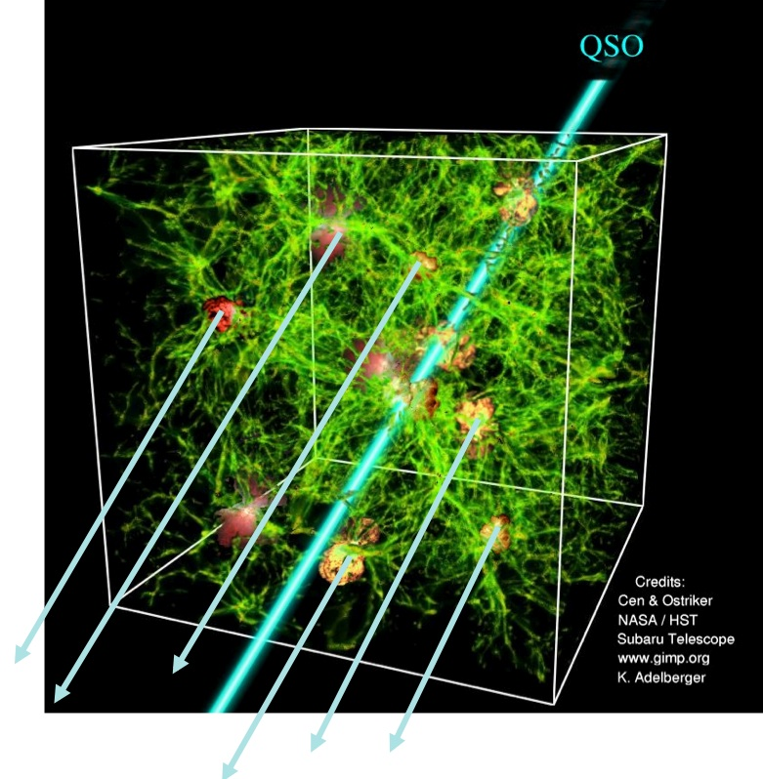
Figure 1: Tomography of the intergalactic medium with WFOS. TMT/WFOS spectroscopy will go ~2.5 mag deeper than 8-10m class telescopes, and background UV-bright galaxies will then become usable beacons. The resulting surface density of sightlines on the sky will increase by 2 orders of magnitude, and it will thus be possible to probe individual galaxy haloes with multiple sightlines. TMT is a wide-field telescope when applied to the high-redshift Universe where a 20’ telescope field of view is equivalent to 3.4° at the typical redshifts in the SDSS.

Top-level Observatory Requirements

Requirement ID | Description | Requirement
[REQ-1-ORD-3950] | Wavelength range | 0.31 – 1.0 µm
[REQ-1-ORD-3955] | Image quality: imaging | ≤ 0.2 arcsec FWHM over any 0.1µm wavelength interval (including contributions from the telescope and the ADC at z = 60°
[REQ-1-ORD-3960] | Image quality: spectroscopy | ≤ 0.2 arcsec FWHM at every wavelength
[REQ-1-ORD-3965] | Field of View | 40.5 arcmin². The field need not be contiguous.
[REQ-1-ORD-3970] | Total Slit Length | ≥ 500 arcseconds
[REQ-1-ORD-3975] | Spatial Sampling | < 0.15 arcsec per pixel, goal < 0.1 arcsec
[REQ-1-ORD-3980] | Spectral Resolution | R = 500-5000 for a 0.75 arcsec slit, 150-7500 (goal)
[REQ-1-ORD-3985] | Throughput | ≥ 30% from 0.31 – 1.0µm, or at least as good as that of the best existing spectrometers
[REQ-1-ORD-3990] | Sensitivity | Spectra should be photon noise limited for all exposure times > 60 sec. Background subtraction systematics must be negligible compared to photon noise for total exposure times as long as 100 Ksec. Nod and shuffle capability in the detectors may be desirable
[REQ-1-ORD-3995] | Wavelength Stability | Flexure at a level of less than 0.15 arcsec at the detector is required

Description

WFOS is a seeing-limited instrument that will cover a total spectral range from 0.31 to 1.1 μm, providing imaging, single object and multi-object spectroscopic modes. It is anticipated that three spectral resolution modes will be available (R = 1000, 5000 and 8000) with multiplexing factors up to 200 objects over a >25 arcmin2 field. The astronomer can select whatever combination of spectral coverage and multiplexing is required by the science, at a given spectral resolution.

A comprehensive Exposure Time Calculator (ETC) covering both the spectroscopic and imaging modes of the instrument has been developed: http://tmt.mtk.nao.ac.jp/ETC-e.html

Studies of possible architectures for WFOS are underway. WFOS is being designed so as not to preclude additional functionality such as a future Ground-Layer Adaptive Optics system for improving the images delivered to the instrument, and thus allowing for higher-sensitivity observations.

References

- Bernstein, R. A., & Bigelow, B. C., “An optical design for a wide-field optical spectrograph for TMT”, 2008, SPIE, 7014, 49

